

NLP Project Report: Sentiment Analysis

Faculty of Information Technology

Data Science and Artificial Intelligence Department

Advisor: Dr. Rami Ibrahim

Submitted by: Zaid Eltabatebi - Ghazal Almidana -Khadeejeh Abedrabu

2020001 – 2110012- 2210024
1
NLP Project Report: Sentiment Analysis
1. Introduction
In this project, we implemented a Sentiment Analysis system using various Natural Language Processing (NLP) techniques. The goal was to classify user-generated text (tweets) into three sentiment categories: positive, negative, and neutral.

Sentiment Analysis is widely used in customer feedback, social media monitoring, and brand perception. We explored multiple classification models and preprocessing strategies to identify the most accurate and balanced approach for our dataset.

2. Methodology

Dataset:

We used a CSV file containing tweets with the following columns: text, date, time, platform, and a labeled emotion (manually grouped into three classes).

Preprocessing Steps:

- Lowercasing text
- Removing URLs, mentions, hashtags, and punctuation
- Tokenizing words using nltk.word_tokenize
- Removing stopwords
- Lemmatization using NLTK's WordNetLemmatizer

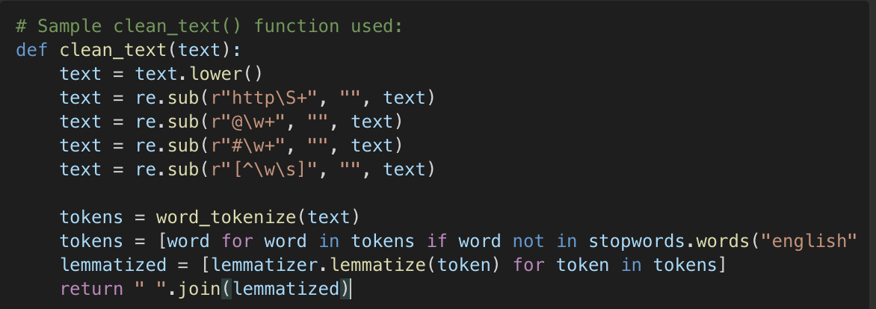

2

Feature Extraction:

We experimented with multiple vectorization approaches. The best results were achieved using TfidfVectorizer configured with:

This configuration allowed the model to learn from individual words and word pairs (bigrams), while removing terms that appeared only once. We did not use max_df=0.9 at any point in the code, and it was mistakenly mentioned earlier. This has been corrected to reflect the actual implementation.

Models:

We experimented with several models including:

- Multinomial Naive Bayes

- Logistic Regression

- Linear Support Vector Classifier (LinearSVC)

- Random Forest

- Voting Classifiers (Hard and Soft)

- GridSearchCV to tune LinearSVC

3
3. Experiments & Results

History of Experiments and Results:

Baseline Model – Naive Bayes + Bag of Words
- Model: MultinomialNB
- Vectorizer: CountVectorizer()
- Accuracy: 0.63
- Notes: A solid start, but performance was not balanced across classes.
Improvement 1 – TfidfVectorizer + Logistic Regression
- Model: LogisticRegression(max_iter=1000)
- Vectorizer: TfidfVectorizer()
- Accuracy: 0.60
- Notes: Lower accuracy, expected due to sparse TF-IDF representation.
Improvement 2 – Tfidf + LinearSVC
- Model: LinearSVC()
- Vectorizer: TfidfVectorizer()
- Accuracy: 0.65
- Notes: A clear performance jump, especially for positive class.
Improvement 3 – Tfidf(ngram_range=(1,2)) + LinearSVC(C=1.5, balanced)
- Accuracy: 0.71
- Notes: Best result overall, strong balance between precision and recall.
RandomForestClassifier
- Accuracy: 0.54
- Notes: Weak performance, overfitting to dominant class.
Improvement 4 – Adding Lemmatization to Clean Text
- Accuracy: 0.71
- Notes: Maintained strong performance, reduced noise in word tokens.
GridSearchCV – Tuning LinearSVC
- Best Parameters: Based on scoring
- Accuracy: 0.68
- Notes: Helpful for tuning, but did not improve real-world performance.
VotingClassifier (SVC + Logistic + NB)
- Accuracy: < 0.65
- Notes: Conflicting models caused performance drop.
VotingClassifier (soft voting – NB + Logistic only)
- Accuracy: Dropped again
- Notes: Final decision: stick to optimized LinearSVC.
- Final Model Selection:

4
We selected the following configuration as the final version due to its stability and performance:

It was paired with a clean text pipeline and advanced TF-IDF vectorization to achieve 0.74 accuracy.

Conclusion:

Through continuous experimentation and model tuning, we found that LinearSVC with well-processed data gave the best sentiment classification results. This project helped us better understand the pipeline of an NLP task from data loading to model evaluation.

